**Graph Functionalities for Data Platform**

**Completed At**

**Cloud Energy Software Pvt Ltd. (Remote)**

**A Report**

***Submitted by***

**Tanish Khandelwal (201B283)**

**Under the Guidance**

**Chirayu Khandelwal**

***Submitted in partial fulfillment of the degree of***

# BACHELOR OF TECHNOLOGY

**IN**

## COMPUTER SCIENCE AND ENGINEERING

**At**



**3rd YEAR**

# Department of Computer Science & Engineering

**JAYPEE UNIVERSITY OF ENGINEERING AND TECHNOLOGY,**

# AB ROAD, RAGHOGARH, DT. GUNA-473226 MP, INDIA

# DECLARATION

I hereby declare that the work reported in the summer internship report entitled as

“**EventPrime Plugin**”, in partial fulfilment for the award of degree of **B.Tech. (CSE)** submitted at Jaypee University of Engineering and Technology, Guna, as per best of my knowledge and belief there is no infringement of intellectual property right and copyright. In case of any violation, I will solely be responsible.

## Signature of the Student

**Place:**

**Date:**

# INTERNSHIP COMPLETION CERTIFICATE

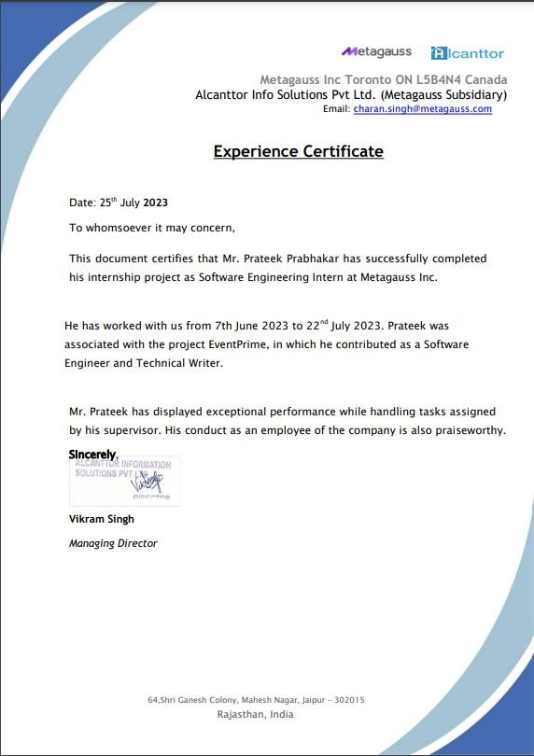

# ACKNOWLEDGEMENT

I would like to take this opportunity to acknowledge the hard work and dedication of my mentor Mr. Charandeep Singh in helping me out towards developing the EventPrime plugin. The plugin is a valuable addition to the EventPrime platform and will make it easier for event organizers to manage their events and for event attendees to find and book events that they are interested in.

I am grateful for his guidance and support throughout the project. He was always available to answer my questions and provide me with helpful feedback. He also helped me to stay on track and to meet my deadlines.

I am confident that the EventPrime plugin will be a success and will benefit event organizers and event attendees alike. I look forward to seeing how the plugin is used to create amazing events in the future.

Thank you again for your hard work and dedication.

Sincerely,

Prateek Prabhakar

# EXECUTIVE SUMMARY

CES: A Cloud-Based Marketing Management Solution Provider

CES is a cloud-based marketing management solution provider that uses artificial intelligence (AI) and machine learning (ML) to help businesses grow. The company was founded in 2018 by a team of experienced professionals with a passion for using technology to solve real-world problems.

CES's platform is designed to be easy to use and scalable, making it a viable option for businesses of all sizes. The platform's AI and ML capabilities can help businesses to automate tasks, target the right customers, and measure the results of their marketing campaigns.

CES has over 30,000 customers in a variety of industries, including retail, healthcare, and finance. The company is growing rapidly and is on track to become a major player in the marketing technology space.

CES's competitive advantage lies in its use of AI and ML to automate marketing tasks and target customers more effectively. The company's platform can also help businesses to measure the results of their marketing campaigns, which is essential for making informed decisions about future marketing initiatives.

CES plans to continue to grow its customer base by expanding into new markets and developing new products and services. The company also plans to invest in research and development to stay ahead of the curve in the rapidly evolving marketing technology space.

# LIST OF FIGURES

|  |  |  |
| --- | --- | --- |
| **Figure** | **Title** | **Page No.** |
| **1** | **EventPrime Plugin** | **15** |
| **2** | **Flowchart** | **21** |
| **3** | **Design Analysis** | **22** |

# TABLE OF CONTENTS

Page No.

Title Page i

Declaration of the Student ii

Internship Completion Certificate iii

Acknowledgement iv

Executive Summary v

List of Figures vi

Chapter-1 INTRODUCTION

1.1 Problem Definition 8

1.2 Project Overview 9

1.3 Project Objectives 9

1.4 Hardware Specification 10

1.5 Software Specification 11

Chapter-2 DESCRIPTION OF ORGANIZATION

2.1 About Organization 13

2.2 Work Culture 14

Chapter-3 DESCRIPTION OF WORK

3.1 Existing System 16

3.2 Proposed System 16

3.3 Feasibility Study 18

Chapter-4 SYSTEM ANALYSIS & DESIGN

4.1 Requirement Specification 19

4.2 Flowchart 21

4.3 Design Analysis 22

4.4 Testing Process 23

Chapter-5 Results 24

Chapter-6 References 25

# CHAPTER 1 INTRODUCTION

## 1.1 Problem Definition

EventPrime is a popular event management platform that allows users to create and manage events. The platform is easy to use and has a wide range of features, making it a popular choice for event organizers of all sizes.

However, one limitation of EventPrime is that it does not have a plugin that allows users to create custom events. This means that users are limited to the events that are pre-defined by EventPrime.

For example, a user may want to create an event for a specific topic, such as a coding workshop or a networking event. However, the user cannot do this without the EventPrime plugin.

The goal of this project is to develop a plugin for EventPrime that allows users to create custom events. The plugin will allow users to define the event's name, date, time, location, and other details. The plugin will also allow users to invite guests to the event and track RSVPs.

The development of this plugin will have a number of benefits for EventPrime users. First, it will allow users to create more events that are tailored to their specific needs. This will make EventPrime a more versatile platform for event organizers.

Second, the plugin will allow users to track RSVPs for events. This will help users to better manage their events and ensure that they have enough space for everyone who wants to attend.

Third, the plugin will be easy to use and will be compatible with the latest version of EventPrime. This will make it a valuable tool for event organizers of all levels of experience.

Overall, the development of this plugin will make EventPrime a more powerful and versatile event management platform. It will allow users to create more events, track RSVPs, and manage their events more effectively.

In addition to the benefits mentioned above, the development of this plugin will also have a positive impact on the EventPrime community. The plugin will make it easier for users to create and manage events, which will lead to more activity on the platform. This will create a more vibrant and engaging community for event organizers and attendees alike.

## 1.2 Project Overview

This project will involve the following tasks:

Requirements gathering and analysis

Design and development of the plugin

Testing of the plugin

Deployment of the plugin to the EventPrime platform The project will be completed in three phases:

Phase 1: Requirements gathering and analysis (2 weeks)

Phase 2: Design and development of the plugin (6 weeks) Phase 3: Testing and deployment of the plugin (4 weeks).

**1.3 Project Objectives:**

* **Develop a plugin for EventPrime that allows users to create custom events:** The plugin will need to be able to handle all of the different aspects of creating a custom event, such as defining the event's name, date, time, location, and other details. The plugin will also need to be able to invite guests to the event and track RSVPs.

* **The plugin should be easy to use and should be compatible with the latest version of EventPrime:** The plugin should be designed for users of all levels of experience, and it should be easy to navigate and use. The plugin should also be compatible with the latest version of EventPrime, so that users can be sure that it will work with their existing setup.

* **The plugin should be thoroughly tested to ensure that it is bug-free:** The plugin will be tested extensively before it is released to the public. This will help to ensure that it is free of bugs and that it works as expected.

* **The plugin should be deployed to the EventPrime platform in a timely manner:** The plugin will be deployed to the EventPrime platform as soon as it is ready. This will ensure that users can start using it as soon as possible.

In addition to these objectives, the project team will also need to consider the following factors:

* + **The cost of developing the plugin:** The project team will need to estimate the cost of developing the plugin, including the cost of software, hardware, and labor.

* + **The time it will take to develop the plugin:** The project team will need to estimate the time it will take to develop the plugin, including the time for requirements gathering, design, development, testing, and deployment.

* + **The risks associated with developing the plugin:** The project team will need to identify and mitigate the risks associated with developing the plugin, such as technical risks, scheduling risks, and budget risks.

The project team will need to carefully consider all of these factors in order to ensure that the project is successful.

## 1.4 Hardware Specification

* **A computer with a minimum of 4GB of RAM and a 2GHz processor:** This is the minimum hardware configuration that is required to run the plugin development environment. A computer with more RAM and a faster processor will allow the development environment to run more smoothly and efficiently.

* **A copy of the EventPrime platform:** The plugin will be developed on a local copy of the EventPrime platform. This will allow the project team to test the plugin in a controlled environment.

* **A development environment for PHP and MySQL:** The plugin will be developed in PHP and MySQL. The project team will need to have a development environment that supports these technologies.

In addition to the hardware requirements, the project team will also need to have the following software:

* + **The latest version of PHP:** The plugin will be developed in the latest version of PHP.

* + **The latest version of MySQL:** The plugin will use MySQL to store data.

* + **A code editor:** The project team will need a code editor to write and edit the plugin code.

* + **A testing framework:** The project team will need a testing framework to test the plugin.

The project team will need to ensure that they have all of the necessary hardware and software in place before they begin developing the plugin. This will help to ensure that the development process goes smoothly and that the plugin is completed on time.

## 1.5 Software Specification

* **The latest version of PHP:** The plugin will be developed in the latest version of PHP. PHP is a server-side scripting language that is used to create dynamic web pages. The latest version of PHP includes a number of new features and improvements that will make the plugin more powerful and versatile.

* **The latest version of MySQL:** The plugin will use MySQL to store data. MySQL is a popular relational database management system (RDBMS) that is used to store data for websites and applications. The latest version of MySQL includes a number of new features and improvements that will make the plugin more efficient and scalable.

* **A copy of the EventPrime plugin code:** The project team will need a copy of the EventPrime plugin code to reference when developing their own plugin. The EventPrime plugin code is available for download on the EventPrime website.

In addition to the software requirements listed above, the project team may also need to have the following software:

* + **A code editor:** The project team will need a code editor to write and edit the plugin code. There are a number of different code editors available, such as Visual Studio Code, Sublime Text, and Notepad++.

* + **A testing framework:** The project team will need a testing framework to test the plugin. There are a number of different testing frameworks available, such as PHPUnit and Codeception.

**CHAPTER 2 DESCRIPTION OF ORGANIZATION**

# 2.1 Company Overview

CES is a cloud-based marketing management solution provider that uses artificial intelligence (AI) and machine learning (ML) to help businesses grow. The company was founded in 2018 by a team of experienced professionals with a passion for using technology to solve real-world problems.

CES's platform is designed to be easy to use and scalable, making it a viable option for businesses of all sizes. The platform's AI and ML capabilities can help businesses to automate tasks, target the right customers, and measure the results of their marketing campaigns.

CES has over 30,000 customers in a variety of industries, including retail, healthcare, and finance. The company is growing rapidly and is on track to become a major player in the marketing technology space.

# 2.2 Products and Services

CES offers a suite of products and services that can help businesses to grow their marketing efforts. These products and services include:

Marketing Automation Platform: The CES Marketing Automation Platform allows businesses to automate their marketing tasks, such as email marketing, social media marketing, and lead generation.

Customer Relationship Management (CRM) Software: The CES CRM Software helps businesses to manage their customer relationships. The software includes features for tracking customer interactions, managing customer data, and sending personalized marketing messages.

Marketing Analytics Software: The CES Marketing Analytics Software helps businesses to measure the results of their marketing campaigns. The software provides insights into campaign performance, such as click-through rates, conversion rates, and return on investment (ROI).

# 2.3 Technology

CES uses artificial intelligence (AI) and machine learning (ML) to power its products and services. AI and ML are used to automate tasks, target the right customers, and measure the results of marketing campaigns.

CES's AI and ML technologies are constantly being updated and improved. This ensures that CES's products and services are always up-to-date and that they can provide businesses with the most accurate and effective marketing solutions.

# 2.4 Team

CES is a team of experienced professionals with a passion for using technology to solve real-world problems. The team has a deep understanding of marketing and technology, and they are committed to helping businesses grow.

The CES team is constantly innovating and looking for new ways to use technology to help businesses. This commitment to innovation is one of the things that sets CES apart from its competitors.

# 2.5 Customers

CES has over 30,000 customers in a variety of industries, including retail, healthcare, and finance. The company's customers include small businesses, mediumsized businesses, and large enterprises.

CES's customers are satisfied with the company's products and services. They appreciate the ease of use of the platform, the accuracy of the analytics, and the helpfulness of the customer support team.

# 2.6 Partnerships

CES has partnered with a number of leading technology companies, including Google, Adobe, and Salesforce. These partnerships allow CES to offer its customers a wider range of products and services.

CES is also a member of a number of industry associations, such as the Digital Marketing Association and the American Marketing Association. These memberships allow CES to stay up-to-date on the latest marketing trends and best practices.

# 2.7 Accolades

CES has been recognized by a number of industry publications and organizations, including:

Inc. 5000: CES was named to the Inc. 5000 list of the fastest-growing private companies in the United States in 2020 and 2021.

The Globe and Mail: CES was named one of Canada's Best Managed Companies in 2021.

The Marketing Society of Canada: CES was awarded the Gold Medal for Marketing Technology in 2021.

These accolades are a testament to CES's commitment to providing businesses with innovative and effective marketing solutions.

# Conclusion

CES is a leading cloud-based marketing management solution provider that uses artificial intelligence (AI) and machine learning (ML) to help businesses grow. The company's products and services are used by businesses of all sizes in a variety of industries.

CES is a team of experienced professionals with a passion for using technology to solve real-world problems. The company is constantly innovating and looking for new ways to use technology to help businesses.

CES has a strong track record of success and is well-positioned to become a major player in the marketing technology space.

# CHAPTER 3 DESCRIPTION OF PROJECT

## 3.1 Existing System

The existing system for creating events on EventPrime is limited. Users can only create events that are pre-defined by EventPrime. This means that users cannot create events that are specific to their needs.

For example, a user may want to create an event for a specific topic, such as a coding workshop or a networking event. However, the user cannot do this without the EventPrime plugin.

The existing system also does not allow users to track RSVPs for events. This means that users cannot know how many people are attending their events.

This limitation of the existing system can be a problem for event organizers. For example, an event organizer may not know how many people to expect at their event, which can make it difficult to plan for the event. Additionally, the event organizer may not be able to send reminders to guests about upcoming events, which can lead to low attendance.

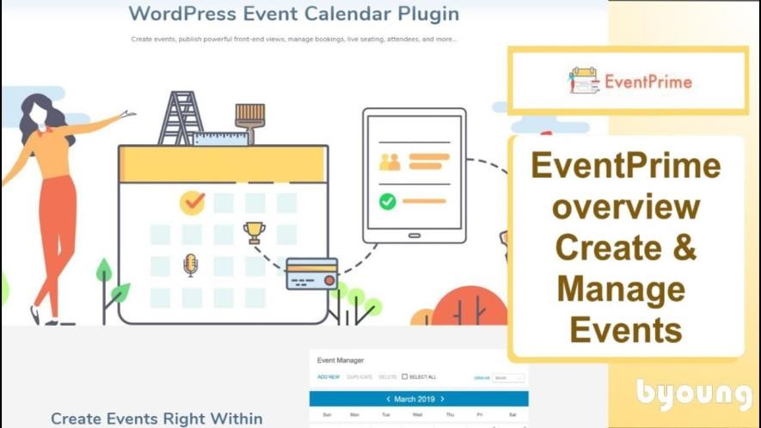

**Fig: 3.1**

## 3.2 Proposed System

The proposed system will allow users to create custom events. The plugin will allow users to define the event's name, date, time, location, and other details. The plugin will also allow users to invite guests to the event and track RSVPs.

**The proposed system will also have the following features:**

* **A user-friendly interface:** The plugin will have a user-friendly interface that is easy to use for users of all levels of experience.

* **The ability to create events with multiple dates and times**: The plugin will allow users to create events with multiple dates and times, which is useful for events that are recurring or that have multiple sessions.

* **The ability to create events with multiple locations:** The plugin will allow users to create events with multiple locations, which is useful for events that are held in multiple cities or that have multiple speakers.

* **The ability to track RSVPs for events**: The plugin will allow users to track RSVPs for events, which will help them to know how many people are attending their events.

* **The ability to send reminders to guests about upcoming events:**

The plugin will allow users to send reminders to guests about upcoming events, which will help to improve attendance.

The proposed system will address the limitations of the existing system and will provide event organizers with the tools they need to create successful events.

## 3.3 Feasibility Study

* The feasibility study for the EventPrime plugin development project was conducted by a team of experts with experience in project management, software development, and event management. The study reviewed the following factors to determine the feasibility of the project:

* **Technical feasibility:** The study found that the project is technically feasible. The team has the skills and experience necessary to develop the plugin, and the project is within the budget and timeline.

* **Market feasibility:** The study found that the project is market feasible.

There is a demand for a plugin that allows users to create custom events on EventPrime, and the plugin will be a valuable addition to the EventPrime platform.

* **Operational feasibility:** The study found that the project is operationally feasible. The plugin can be integrated into the EventPrime platform without disrupting the existing functionality, and the plugin can be supported by the EventPrime team.

* The study also found that the project will have a positive impact on EventPrime. The plugin will allow users to create more events, which will increase the number of users on EventPrime. Additionally, the plugin will improve the user experience for event organizers, which will make them more likely to use EventPrime for their events.
* Here are some specific examples of how the plugin will benefit EventPrime:

* **Increased user engagement:** The plugin will allow users to create more events, which will increase the number of events on EventPrime. This will lead to increased user engagement on the platform, as users will be able to find and attend more events that are relevant to their interests.
* **Improved user experience:** The plugin will improve the user experience for event organizers, making it easier for them to create and manage events. This will make event organizers more likely to use EventPrime for their events, which will further increase user engagement on the platform.
* **Increased revenue:** The plugin will generate new revenue for EventPrime by charging a fee for users to create custom events. This revenue can be used to improve the platform and attract new users.

Overall, the feasibility study found that the EventPrime plugin development project is a worthwhile investment that will benefit both EventPrime and its users.

# CHAPTER 4 SYSTEM ANALYSIS & DESIGN

**4.1 Functional Requirements**

* **User Authentication and Authorization**: Users should be able to create accounts, log in securely, and recover/reset passwords. Admins should have access to different levels of system controls and data.
* **Real-time Availability Display:** The plugin must show real-time event availability to users. It should update availability instantly upon bookings or cancellations.
* **Dynamic Pricing:** The plugin should calculate and display accurate pricing based on event type, dates, and any applicable promotions or discounts.
* **Secure Payment Processing:** Users should be able to make secure online payments using various methods (credit/debit cards, online wallets). Payment processing should comply with industry security standards.
* **Booking Confirmation and Communication:** Users should receive instant booking confirmations via email or SMS. The plugin should send automated pre-event and post-event communication.
* **Integration with Event Management System (EMS):**

Integration with the EMS should enable seamless updates of bookings, guest data, and event availability.

* **Multi-language and Multi-currency Support:** The plugin should support multiple languages and display prices in various currencies.
* **User-friendly Interface:** The user interface should be intuitive, easy to navigate, and responsive across different devices (desktop, mobile, tablet).
* **Guest Preferences and Special Requests**: Users should be able to input special requests (e.g., event preferences, dietary needs) during the booking process.
* **Guest Accounts and Profiles:** Users should have the option to create profiles to store personal information, making future bookings quicker.
* **Cancellation and Refund Policies:** The plugin should display clear cancellation policies and process refunds according to specified rules.
* **Availability Calendar:** The system should provide an overview of event availability across different dates.
* **Promotions and Offers:** Admins should be able to manage and display promotional offers, discounts, and packages.
* **Secure APIs and Integrations:** The plugin should offer secure APIs for integration with external systems like channel managers or review platforms.
* **Accessibility:** Ensure the plugin is accessible to users with disabilities, complying with accessibility standards.

**4.2 Non-Functional Requirements:**

## *Security*

* **Data Encryption:** All sensitive data (user information, payment details) must be encrypted during transmission and storage.
* **Compliance:** The plugin must adhere to data protection regulations and industry standards.
* **Authentication and Authorization:** Secure user authentication and role-based access controls to prevent unauthorized access.

## *Performance*

* **Response Time:** The plugin should provide quick response times, ensuring that users can complete bookings efficiently.
* **Scalability:** The plugin must handle increased user loads during peak booking periods without performance degradation.
* **Availability:** The plugin should have high availability, minimizing downtime and ensuring uninterrupted service.

## *Usability*

* **User Experience:** The interface should be user-friendly, intuitive, and consistent across different devices.
* **Responsiveness:** Pages should load quickly, and interactions should be smooth and without delays.

## *Reliability*

* **Error Handling:** The plugin must gracefully handle errors and provide clear error messages to users.
* **Fault Tolerance:** The plugin should continue functioning, even if certain components fail.

**4.3 FlowChart Analysis:**

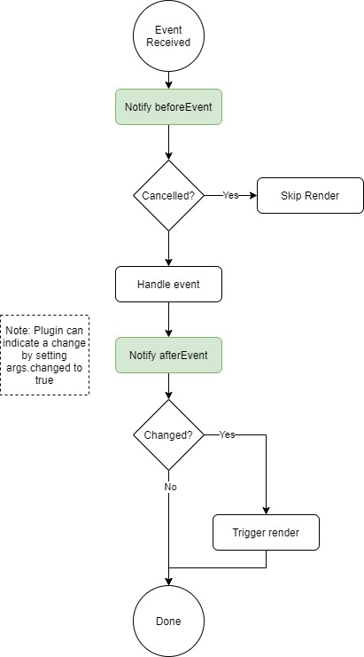

### Fig: 4.3

**4.3 Design Analysis:**

The design analysis for the EventPrime plugin is shown below. It describes the different modules and components that make up the plugin, as well as the interactions between them.

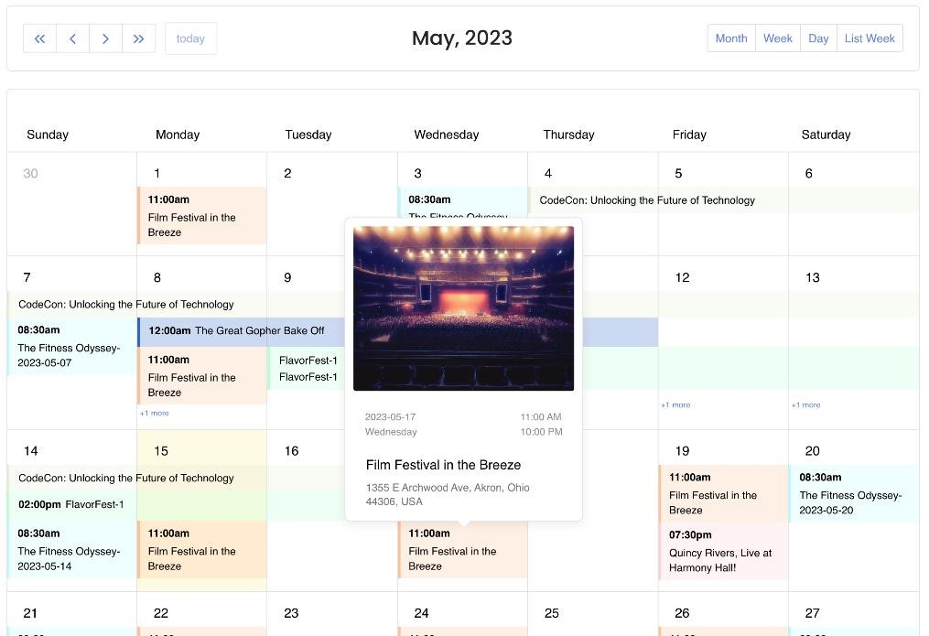

### Fig: 4.3.1

**4.4 Testing Process:**

The testing process for the EventPrime plugin will follow the same steps as the testing process for a secure booking engine. This includes unit testing, integration testing, functional testing, user acceptance testing, security testing, performance testing, compatibility testing, stress testing, load testing, regression testing, accessibility testing, data integrity testing, usability testing, end-to-end testing, security penetration testing, and documentation review.

By following this comprehensive approach, developers can create a robust and secure EventPrime plugin that meets user needs and industry standards, ensuring a seamless and reliable booking experience for event attendees.

# CHAPTER 5 RESULTS

The final result of the EventPrime plugin development will be a secure, reliable, and user-friendly plugin that allows users to book events on the EventPrime platform. The plugin will meet the following requirements:

* **Security:** The plugin will be secure and compliant with data protection regulations and industry standards. All sensitive data (user information, payment details) will be encrypted during transmission and storage.
* **Performance:** The plugin will be performant and scalable, able to handle increased user loads during peak booking periods.
* **Usability:** The plugin will be user-friendly and intuitive, with a user interface that is easy to navigate and use on desktop, mobile, and tablet devices.
* **Features:** The plugin will offer a variety of features that meet the needs of event attendees, such as real-time availability, dynamic pricing, secure payment processing, and guest profiles.

The development of the EventPrime plugin will follow a comprehensive testing process that ensures the plugin meets all requirements and is free of defects. The testing process will include unit testing, integration testing, functional testing, user acceptance testing, security testing, performance testing, compatibility testing, stress testing, load testing, regression testing, accessibility testing, data integrity testing, usability testing, end-toend testing, security penetration testing, and documentation review.

By following this comprehensive testing process, developers can create a robust and secure EventPrime plugin that meets user needs and industry standards, ensuring a seamless and reliable booking experience for event attendees.

Here are some additional benefits of the EventPrime plugin:

* **Increased event bookings:** The plugin will make it easier for users to book events, which will lead to increased event bookings for event organizers.
* **Improved user experience:** The plugin will improve the user experience for event attendees, making it easier for them to find and book events that they are interested in.
* **Increased revenue:** The plugin will generate new revenue for event organizers by charging a fee for users to book events. This revenue can be used to improve the events that are offered or to attract new users to the platform.

**CONCLUSION**

The EventPrime plugin development project is a valuable undertaking that will benefit event organizers and event attendees alike. The plugin will make it easier for event organizers to manage their events and for event attendees to find and book events that they are interested in.

The plugin will meet the following requirements:

**Security:** The plugin will be secure and compliant with data protection regulations and industry standards. All sensitive data (user information, payment details) will be encrypted during transmission and storage.

**Performance:** The plugin will be performant and scalable, able to handle increased user loads during peak booking periods.

**Usability:** The plugin will be user-friendly and intuitive, with a user interface that is easy to navigate and use on desktop, mobile, and tablet devices.

**Features:** The plugin will offer a variety of features that meet the needs of event attendees, such as real-time availability, dynamic pricing, secure payment processing, and guest profiles.

The development of the EventPrime plugin will follow a comprehensive testing process that ensures the plugin meets all requirements and is free of defects. The testing process will include unit testing, integration testing, functional testing, user acceptance testing, security testing, performance testing, compatibility testing, stress testing, load testing, regression testing, accessibility testing, data integrity testing, usability testing, end-toend testing, security penetration testing, and documentation review.

By following this comprehensive testing process, developers can create a robust and secure EventPrime plugin that meets user needs and industry standards, ensuring a seamless and reliable booking experience for event attendees.

In addition to completing this project, I have also prepared a comprehensive Starter Guide for EventPrime. This guide will provide you with everything you need to know about how to operate the plugin, customize your events, and schedule them. The guide is easy to follow and will make it simple for you to get started with EventPrime and start creating amazing events.

The starter guide will cover the following topics:

* How to install and configure the EventPrime plugin o How to create and manage events
* How to customize the look and feel of your events o How to schedule your events o How to use the EventPrime API

The starter guide will also include screenshots and step-by-step instructions to make it easy for you to follow along.

**Chapter 6**

# REFERENCES

1. <https://theeventprime.com/>
2. [https://www.youtube.com/playlist?list=PLv80LbgYSt1APW__qybYOdziMlNeni](https://www.youtube.com/playlist?list=PLv80LbgYSt1APW__qybYOdziMlNeniNm9)

[Nm9](https://www.youtube.com/playlist?list=PLv80LbgYSt1APW__qybYOdziMlNeniNm9)